

Subjective and Objective Assessment Form

Client Name
Phone number
Therapist Name
Date of consultation
D.O.B
Age
Allergies
Medical conditions

Relevant Medical history
Medications
General health/ lifestyle/ social
Sporting profile- type of sport, level and weekly training plan
Current issue
Location of issue  Mark areas | 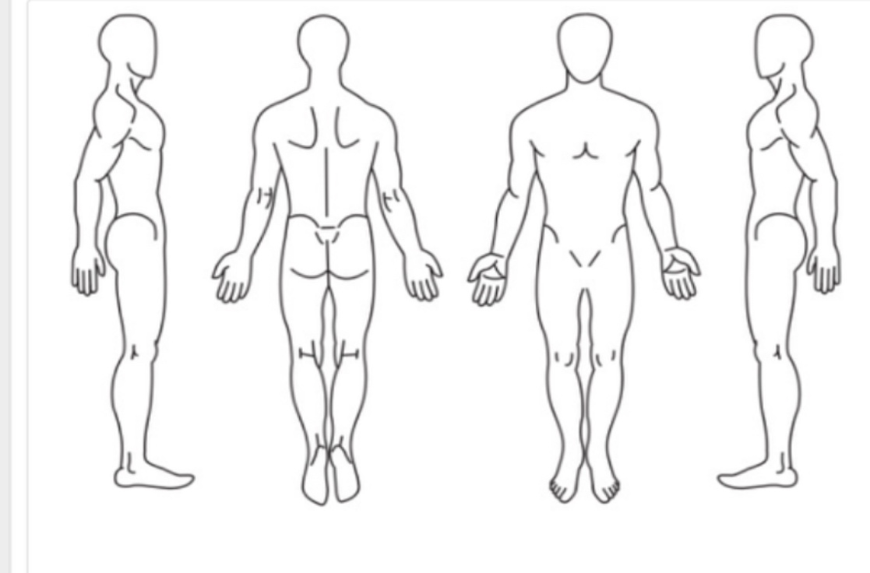
Symptoms
Anything improve symptoms?
Make symptoms worse
Contraindications/ cautions
Goals of treatment
Consent to consultation & secure storage of confidential information for treatment or referral purposes and in accordance with current GDPR (2018) legislation - client date and signature
Chaperone Required? | Yes/ No
Chaperone signature
Therapist date and signature

Initial Assessment – for completion by therapist

Gait- does each foot pass during swing phase?
Wide or narrow stance?
Body Type
Posture;
Neck
spine
Shoulder blades
Hips
Creases
Knees
Calves
Ankles
Feet- rotation in/ev
Tests
Strength L/R 1-5
Special tests

ROM hips
Lower back
Shoulders
Any issues identified
Treatment plan
Treatment given
Plan- exercises/ stretches frequency

Continuation Sheet

Date | Issue change/ new issue | Medication / health Changes | Treatment Plan (Details) | Treatment Given/ exercises  (Details) | Client Signature | Therapist Signature

